1. TE10 Mode Simulation: A WR-90 rectangular waveguide has a = 22.86 mm, b = 10.16 mm and length L = 100 mm. Operate it at f = 10 GHz and excite the dominant TE10 mode in HFSS. Obtain the E-field and H-field distributions, simulated cutoff frequency fc and propagation constant β. Calculate fc (theory) = c/(2a), β = (2πf/c)√[1−(fc/f)²], and the percentage deviation of simulated fc from theoretical fc.
Code:

clc; clear; close all;

%% WR-90 Waveguide Parameters
a = 22.86e-3; % Width (m)
b = 10.16e-3; % Height (m) L = 100e-3; % Length (m)
c = 3e8; % Speed of light (m/s)
f = 10e9; % Operating frequency (Hz)

%% 1. Calculate Theoretical Values fc_theory = c/(2*a);
lambda0 = c/f;
k0 = 2*pi/lambda0;

beta = k0*sqrt(1-(fc_theory/f)^2);

fprintf('\n====================================\n'); fprintf(' TE10 MODE ANALYSIS - PART A\n'); fprintf('====================================\n');

fprintf('\nOUTPUT 1: E-FIELD DISTRIBUTION\n');
fprintf('TE10 electric field varies sinusoidally across width.\n');

fprintf('\nOUTPUT 2: H-FIELD DISTRIBUTION\n');
fprintf('TE10 magnetic field has transverse and longitudinal components.\n');

fprintf('\nOUTPUT 3: CUTOFF FREQUENCY\n');
fprintf('Theoretical Cutoff Frequency = %.4f GHz\n', ... fc_theory/1e9);

fprintf('\nOUTPUT 4: PROPAGATION CONSTANT\n');
fprintf('Propagation Constant Beta = %.4f rad/m\n', beta); fprintf('\nOUTPUT 5: MODE DECISION\n');
if f > fc_theory
fprintf('TE10 mode propagates at %.2f GHz.\n', f/1e9); else
fprintf('TE10 mode is below cutoff.\n'); end

%% Field Coordinates Nx = 100;
Ny = 60;

x = linspace(0,a,Nx); y = linspace(0,b,Ny);
[X,Y] = meshgrid(x,y);

%% E-field Distribution Ey = sin(pi*X/a);

figure(1); surf(X*1000,Y*1000,Ey); shading interp;
colorbar;
xlabel('Width x (mm)');

ylabel('Height y (mm)'); zlabel('Normalized E_y');
title('Output 1: TE10 E-Field Distribution'); view(45,30);

%% H-field Distribution Hx = -sin(pi*X/a);
Hz = cos(pi*X/a);

figure(2); subplot(1,2,1);
surf(X*1000,Y*1000,Hx); shading interp;
colorbar;
xlabel('Width x (mm)');
ylabel('Height y (mm)'); title('H_x Distribution');

subplot(1,2,2); surf(X*1000,Y*1000,Hz); shading interp;
colorbar;
xlabel('Width x (mm)');
ylabel('Height y (mm)'); title('H_z Distribution');

sgtitle('Output 2: TE10 H-Field Distribution');

%% Cutoff Frequency Comparison
% Enter the simulated cutoff frequency obtained from HFSS. fc_sim_GHz = NaN;

figure(3); bar([fc_theory/1e9, 0]);

set(gca,'XTickLabel',{'Theoretical','HFSS Simulated'}); ylabel('Cutoff Frequency (GHz)');
title('Output 3: Cutoff Frequency Comparison'); grid on;

if ~isnan(fc_sim_GHz) figure(3);
bar([fc_theory/1e9, fc_sim_GHz]); set(gca,'XTickLabel',{'Theoretical','HFSS Simulated'}); ylabel('Cutoff Frequency (GHz)');
title('Output 3: Cutoff Frequency Comparison'); grid on;

deviation = abs(fc_sim_GHz-fc_theory/1e9) ...
/(fc_theory/1e9)*100;

fprintf('HFSS Cutoff Frequency = %.4f GHz\n',fc_sim_GHz); fprintf('Cutoff Frequency Deviation = %.3f %%\n',deviation);
else
fprintf('\nEnter the HFSS cutoff frequency in fc_sim_GHz to compare.\n'); end

%% Propagation Constant Output figure(4);
bar(beta);
ylabel('Propagation Constant (rad/m)'); title('Output 4: TE10 Propagation Constant'); grid on;

%% Mode Decision figure(5); bar([fc_theory/1e9, f/1e9]);
set(gca,'XTickLabel',{'Cutoff Frequency','Operating Frequency'}); ylabel('Frequency (GHz)');

title('Output 5: TE10 Mode Propagation Decision'); grid on;

fprintf('\n====================================\n'); fprintf('THEORETICAL SUMMARY\n');
fprintf('Cutoff Frequency = %.4f GHz\n',fc_theory/1e9); fprintf('Operating Frequency = %.2f GHz\n',f/1e9); fprintf('Propagation Constant = %.4f rad/m\n',beta); fprintf('====================================\n');
Out put:
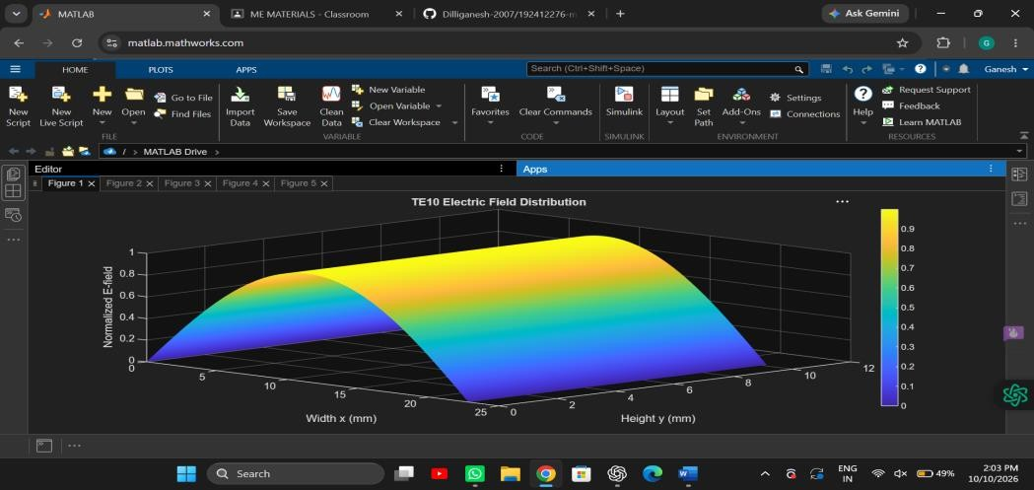
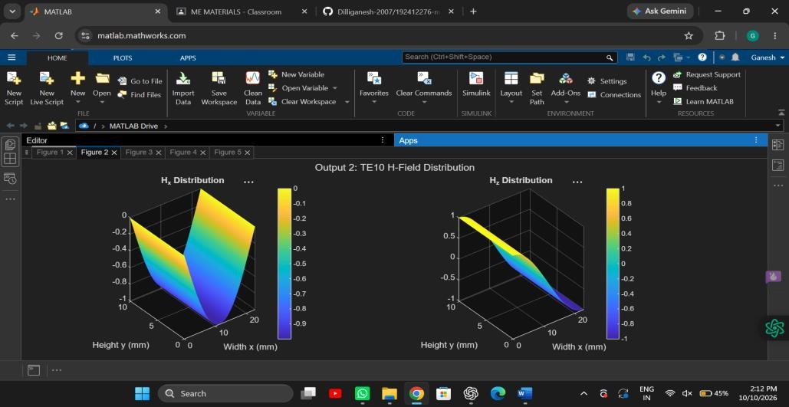

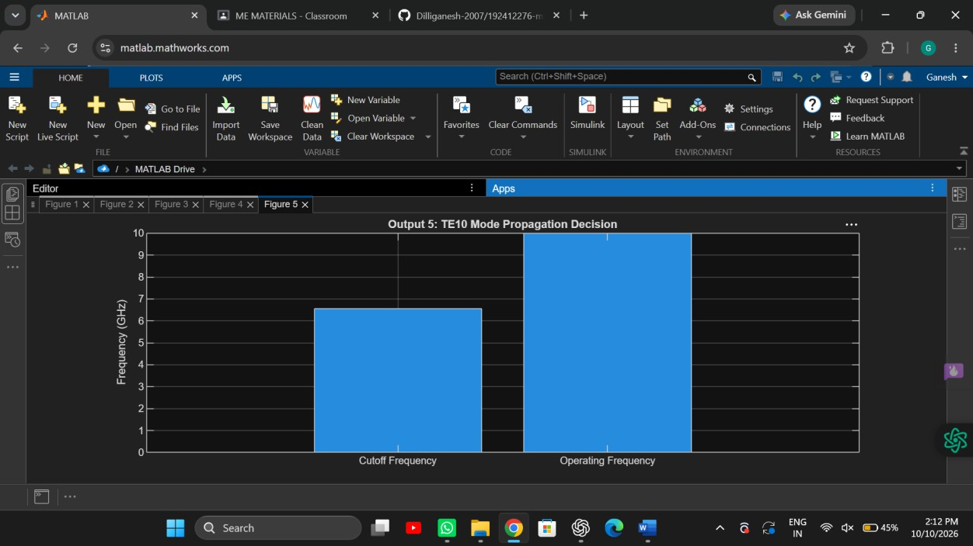

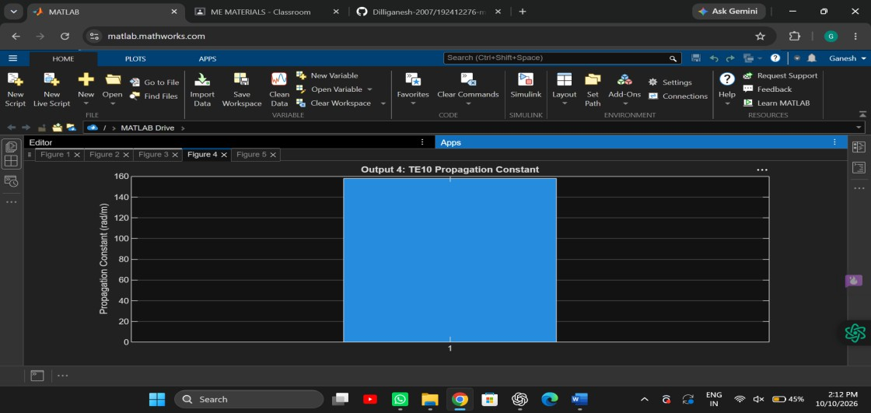

1. TE10 versus TM11: Using the same WR-90 waveguide at f = 10 GHz,

simulates both TE10 and TM11 modes. Determine fc, β and the E/H-field distributions for each mode. Calculate the theoretical cutoff frequencies using fc(mn)=c/2√[(m/a)²+(n/b)²]. Compare the results and justify why TE10 propagates at 10 GHz while TM11 does not.

Code:

clc; clear; close all;

%% WR-90 Waveguide Parameters
a = 22.86e-3; % Width (m)
b = 10.16e-3; % Height (m) L = 100e-3; % Length (m)
c = 3e8; % Speed of light (m/s)
f = 10e9; % Operating frequency (Hz)

%% 1. Theoretical Cutoff Frequencies
% TE10 mode fc_TE10 = c/(2*a);

% TM11 mode
m = 1;
n = 1;
fc_TM11 = (c/2)*sqrt((m/a)^2 + (n/b)^2);

%% 2. Propagation Constants k0 = 2*pi*f/c;

% TE10 propagation constant
beta_TE10 = sqrt(complex(k0^2-(2*pi*fc_TE10/c)^2));

% TM11 propagation constant
beta_TM11 = sqrt(complex(k0^2-(2*pi*fc_TM11/c)^2));

%% 3. Display Results fprintf('\n====================================\n'); fprintf(' TE10 vs TM11 WAVEGUIDE ANALYSIS\n'); fprintf('====================================\n');

fprintf('Operating Frequency: %.2f GHz\n\n',f/1e9);

fprintf('TE10 Cutoff Frequency: %.4f GHz\n', ... fc_TE10/1e9);

fprintf('TM11 Cutoff Frequency: %.4f GHz\n\n', ... fc_TM11/1e9);

fprintf('TE10 Propagation Constant: %.4f rad/m\n', ... real(beta_TE10));

fprintf('TM11 Propagation Constant: %.4f rad/m\n\n', ... real(beta_TM11));

%% 4. Mode Propagation Decision if f > fc_TE10
fprintf('TE10: PROPAGATING MODE\n');
else
fprintf('TE10: BELOW CUTOFF\n'); end

if f > fc_TM11
fprintf('TM11: PROPAGATING MODE\n');
else
fprintf('TM11: BELOW CUTOFF\n'); end

%% 5. Field Distribution Coordinates Nx = 100;
Ny = 60;

x = linspace(0,a,Nx); y = linspace(0,b,Ny);
[X,Y] = meshgrid(x,y);

%% 6. TE10 Electric and Magnetic Field Patterns
% Normalized spatial field patterns E_TE10 = sin(pi*X/a);

Hx_TE10 = -sin(pi*X/a); Hz_TE10 = cos(pi*X/a);

%% 7. TM11 Electric and Magnetic Field Patterns
% TM11 spatial field patterns Ez_TM11 = sin(pi*X/a).*sin(pi*Y/b);

Ex_TM11 = cos(pi*X/a).*sin(pi*Y/b); Ey_TM11 = sin(pi*X/a).*cos(pi*Y/b);

Hx_TM11 = -Ey_TM11; Hy_TM11 = Ex_TM11;

%% 8. Plot TE10 E-field figure; surf(X*1000,Y*1000,E_TE10);
shading interp; colorbar;
xlabel('Width x (mm)');
ylabel('Height y (mm)'); zlabel('Normalized E-field');

title('TE10 Electric Field Distribution'); view(45,30);

%% 9. Plot TE10 H-field figure;
quiver(X*1000,Y*1000,Hx_TE10,Hz_TE10); xlabel('Width x (mm)');
ylabel('Height y (mm)');
title('TE10 Magnetic Field Pattern'); axis equal tight;

%% 10. Plot TM11 E-field figure; surf(X*1000,Y*1000,Ez_TM11);
shading interp; colorbar;
xlabel('Width x (mm)');
ylabel('Height y (mm)'); zlabel('Normalized E_z');
title('TM11 Electric Field Distribution'); view(45,30);

%% 11. Plot TM11 H-field figure;
quiver(X*1000,Y*1000,Hx_TM11,Hy_TM11); xlabel('Width x (mm)');
ylabel('Height y (mm)');
title('TM11 Magnetic Field Pattern'); axis equal tight;

%% 12. Cutoff Frequency Comparison figure;
bar([fc_TE10 fc_TM11]/1e9); set(gca,'XTickLabel',{'TE10','TM11'});

ylabel('Cutoff Frequency (GHz)'); title('TE10 vs TM11 Cutoff Frequency'); grid on;

%% 13. Calculate Percentage Deviation
% Enter simulated cutoff frequencies from HFSS in GHz. fc_TE10_sim_GHz = NaN;
fc_TM11_sim_GHz = NaN;

if ~isnan(fc_TE10_sim_GHz)
deviation_TE10 = abs(fc_TE10_sim_GHz*1e9 ...
-fc_TE10)/fc_TE10*100;
fprintf('\nTE10 Cutoff Deviation: %.3f %%\n', ... deviation_TE10);
end

if ~isnan(fc_TM11_sim_GHz)
deviation_TM11 = abs(fc_TM11_sim_GHz*1e9 ...
-fc_TM11)/fc_TM11*100;
fprintf('TM11 Cutoff Deviation: %.3f %%\n', ... deviation_TM11);
end

Output:

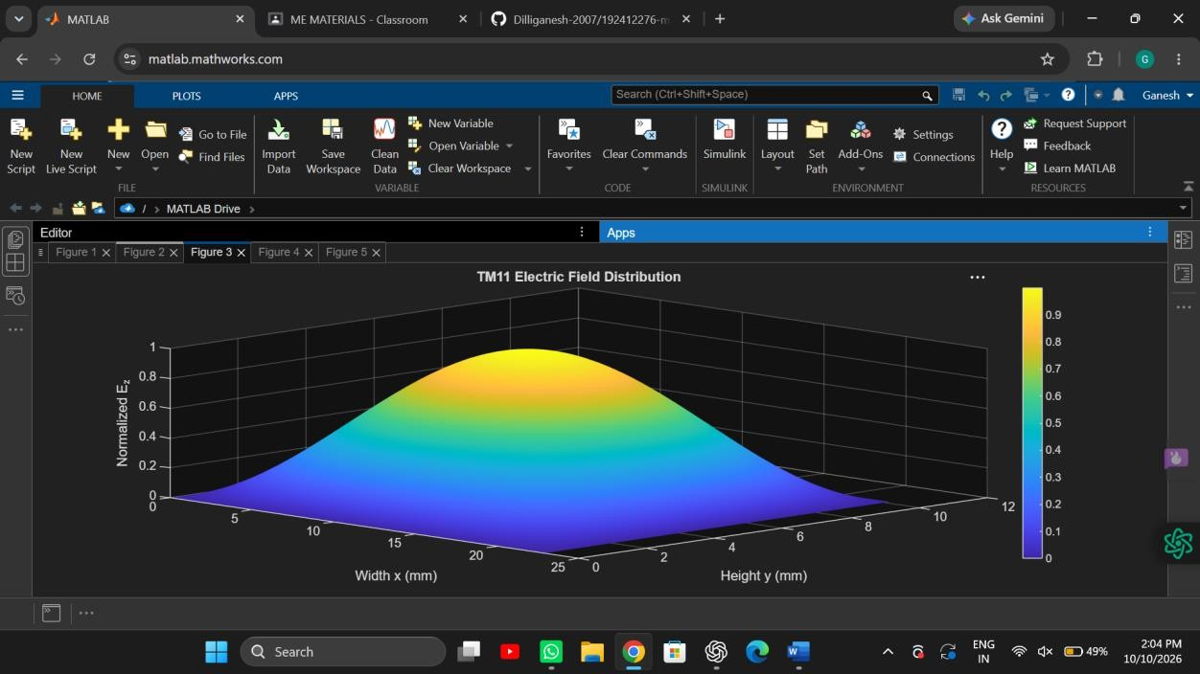
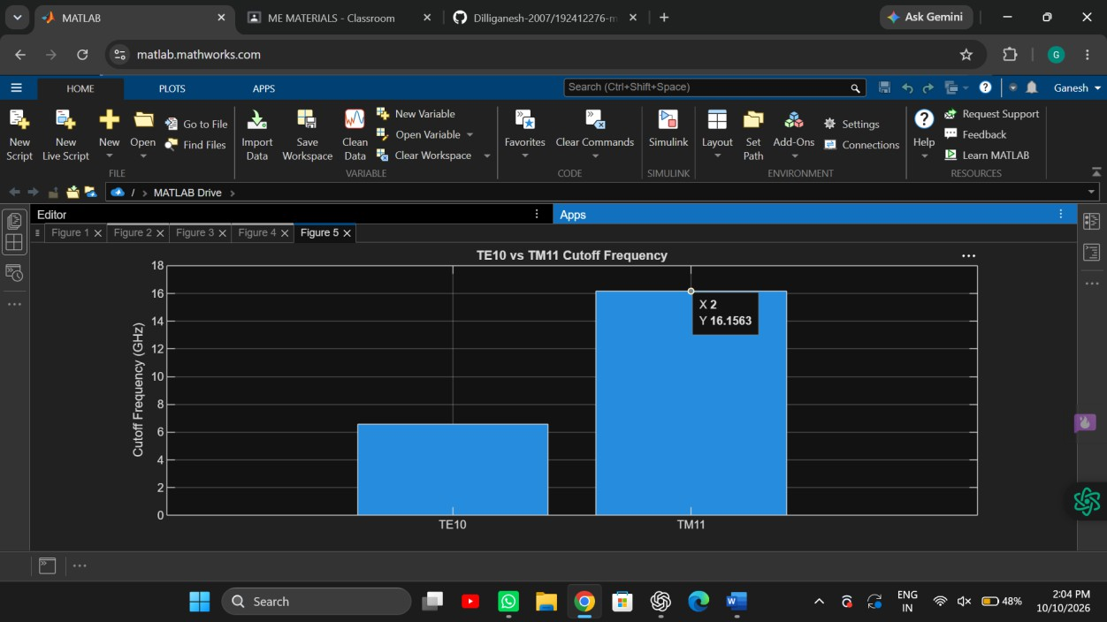

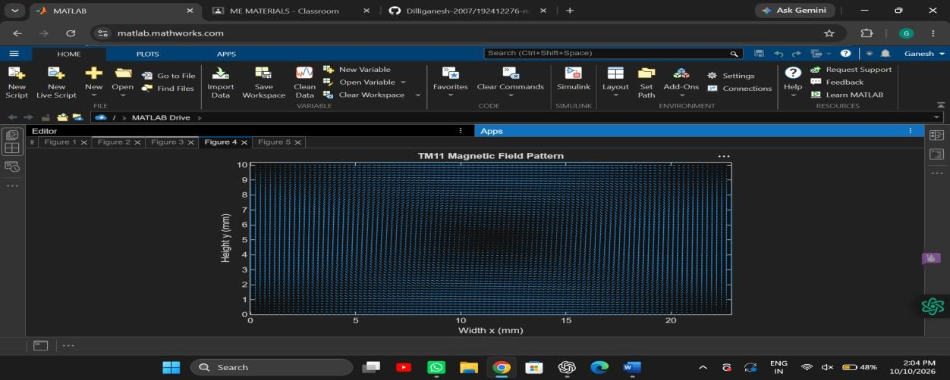
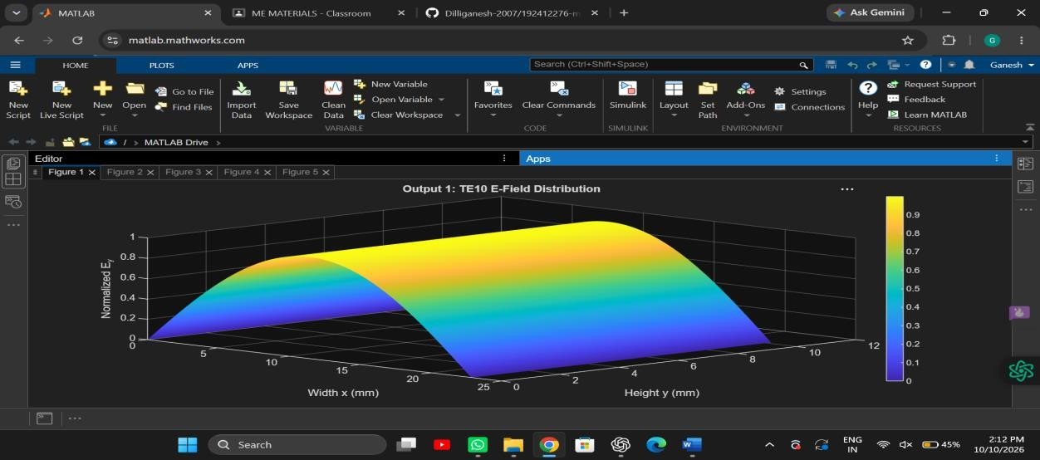
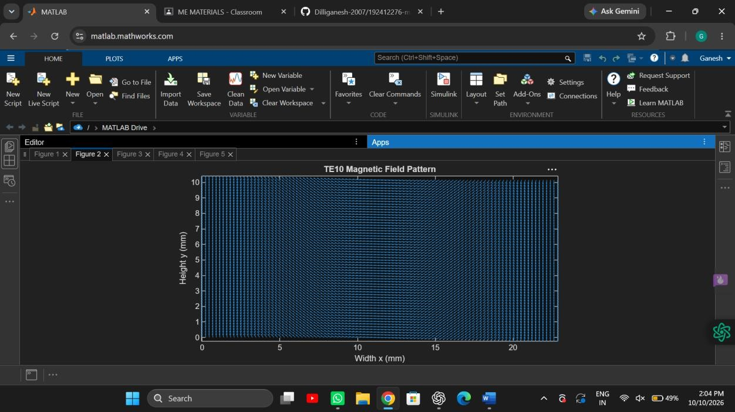

S.No. | Output Parameter | Theoretical / Expected Value | Practical / Simulated Value | % Deviation

1 | E-field distribution | TE10/TM11 field pattern | Record HFSS plot | —
2 | H-field distribution | TE10/TM11 field pattern | Record HFSS plot | —
3 | Cutoff frequency | TE10 = 6.557 GHz; TM11  ≈ 16.42 GHz | Record HFSS value | % deviation
4 | Propagation constant | TE10 ≈ 198.9 rad/m at 10 GHz | Record HFSS value | % deviation
5 | Mode decision | TE10 propagates; TM11 is below cutoff | Record observation | —

